**Automating Eclipse PDE Unit Tests using Ant**

**Summary**

This article outlines how to integrate your PDE unit tests into an Ant based automated build, using a simple Eclipse plug-in as an example, some simple java classes, basic Eclipse plug-in techniques and some standard Ant tasks.

**By Brian Joyce, [Duolog Technologies Ltd., Galway, Ireland](http://www.duolog.com/" \t "_blank)**

Copyright © 2008, Brian Joyce

June 13, 2008

**Introduction**

It's generally accepted that writing tests as part of software development is a very good thing indeed. It's also generally accepted that automating the running of tests in an automated or nightly build is good engineering practice. Let's face it, if tests are not run automatically then there's a good chance they won't be run at all, and tests that are not run are next to useless.

The Eclipse Plug-in Development Environment (PDE) provides a excellent framework for developing plug-ins and also provides facilities to write and run PDE unit tests for your plug-ins that can be run from within the Eclipse environment.

Once you have taken the time and effort to write these valuable PDE unit tests, how do you automate the running of these PDE unit tests so that you can integrate them into your automated build?

Searching the web provides several options for automating PDE tests such as:

* Markus Barchfeld's excellent [**Build and Test Automation for plug-ins and features**](http://www.eclipse.org/articles/Article-PDE-Automation/automation.html) article which details setting up automatic building and testing for an Eclipse plug-in using the Eclipse headless build.
* [**Eclipse Test Framework**](http://dev.eclipse.org/viewcvs/index.cgi/org.eclipse.test/testframework.html?view=co).
* Patrick Paulin's RCP Quickstart post on [**Running Automated Tests with PDE Build.**](http://rcpquickstart.wordpress.com/2007/08/06/running-automated-tests-with-pde-build/)
* Some more excellent links can be found at [**6 Great Links for Eclipse Build Automation with PDE Build**](http://eclipsenuggets.blogspot.com/2007/09/6-great-links-for-eclipse-build.html).

As you can see writing PDE Tests can be complex, running PDE Tests from the command line can be complex too, but running them and collecting the results in a format that can be easily interpreted (e.g. Junitreport format) is even more difficult.

This article provides a detailed example application, the enabling technology to collect and format test results (see [**PDE Test Utilities**](file:///E:\%E6%AF%8F%E6%97%A5%E6%9B%B4%E6%96%B0\0529\article.php.htm#PDE_Test_Utilities) ), and a build system that demonstrates a generic mechanism for running PDE Tests using Ant, allowing you to integrate it with any Ant build system.

This PDE Test technique provides the following benefits:

1. Allows you to run your PDE Tests from the command line
2. Allows you to collect the PDE Tests results in a format that can be easily interpreted (i.e. Junitreport format)
3. Allows you to integrate PDE Tests into any Ant-based build system

**Note:** all the techniques and examples detailed in this article have been tested against Eclipse 3.3 (specifically Eclipse 3.3.2 and 3.3.1.1) on Windows XP only and using [**Ant 1.7.0**](http://ant.apache.org/bindownload.cgi) . There is also an [**Eclipse 3.1 version**](http://www.eclipse.org/articles/Article-PDEJUnitAntAutomation/PDETestExampleProjects-3.1.zip) of the example code.

**Overview**

PDE unit tests are automated as follows:

***Prerequisites:***

1. A dedicated PDE test Eclipse installation that is only used by the automated build system.
2. For each Eclipse plug-in *A* that is to be tested, an Eclipse plug-in fragment *A-test* for *A* that only contains the PDE unit tests and their test dependencies for the plug-in *A*.
3. A pre-defined (or specified) PDE test port.
4. A PDE test listener class to listen on the PDE test port for the results from the PDE test run.
5. A list of PDE test classes to be run as part of the PDE Test run

***Running the PDE unit tests:***

See [**Figure 1**](file:///E:\%E6%AF%8F%E6%97%A5%E6%9B%B4%E6%96%B0\0529\article.php.htm#Figure_1_-_Overview_diagram_of_the_PDE) below for a visual representation of the PDE test steps.

1. Deploy plug-in *A* and plug-in fragment *A-test* into a pristine PDE test Eclipse installation.
2. Select PDE test port (or use predefined reserved port).
3. Start the PDE test listener process that listens on the PDE test port.Startup the PDE test Eclipse installation, specifying the list of unit test classes to be run, and the PDE test port to output test progress and results to.
4. The PDE test Eclipse installation starts up and automatically runs the specified tests and outputs the results to the PDE test port where the PDE test listener process captures the results and outputs them in standard Ant **[junit](http://ant.apache.org/manual/OptionalTasks/junit.html" \t "_blank)** task XML format.
5. Run the regular Ant **[junitreport](http://ant.apache.org/manual/OptionalTasks/junitreport.html" \t "_blank)** task on the generated test results XML files.
6. That's it: you now have a typical Ant JUnit HTML report containing your PDE unit test results.

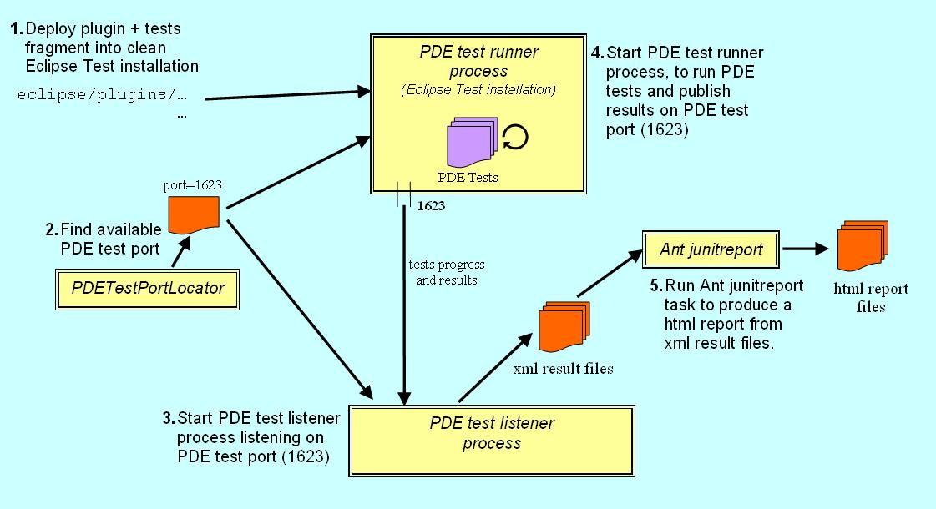

Figure 1 - Overview diagram of the PDE Test steps

**Prerequisites**

This section describes the prerequisites for using this technique in more detail.

***Dedicated PDE test Eclipse installation***

In order to run the PDE Tests you need a separate Eclipse installation whose sole purpose is for running the PDE Tests. Having a dedicated Eclipse installation provides a pristine and repeatable test environment and avoids any possible conflicts or corruption that might occur with a typical development Eclipse installation.

***Use an Eclipse plug-in fragment for the PDE Unit Tests for a plug-in***

This technique promotes the use of [**Eclipse plug-in fragments**](http://help.eclipse.org/help33/topic/org.eclipse.platform.doc.isv/guide/product_def_plugins.htm) to develop PDE Unit tests for plug-ins, so for each Eclipse plug-in *A* that is to be tested, an Eclipse plug-in fragment *A-test* for *A* that only contains the PDE unit tests and their test dependencies for the plug-in *A*.

You can of course develop the PDE tests directly in the plug-in (in a test directory), but this can lead to unwanted dependencies in your plug-in and involves slightly more complicated packaging for your plug-in (i.e. without test classes and test dependencies).

The Eclipse plug-in fragment approach avoids these pitfalls and although it requires a little more setup initially it provides a cleaner and clearer mechanism for defining PDE Tests and also provides a straightforward way for the build system of identifying which plug-ins have PDE Tests associated with them.

For a good description and more general discussion of using Eclipse plug-in fragments for testing, see Patrick Paulin's RCP Quickstart article[**Testing Plug-ins with Fragments**](http://rcpquickstart.wordpress.com/2007/06/20/unit-testing-plug-ins-with-fragments/).

***PDE test port***

In order for the PDE test runner and the PDE test listener processes to communicate, both processes need to use a predefined or specified port so that the PDE test runner can send the test progress and results to the PDE test listener process. In the example code we use a utility class[pde.test.utils.PDETestPortLocator](file:///E:\%E6%AF%8F%E6%97%A5%E6%9B%B4%E6%96%B0\0529\article.php.htm#PDETestPortLocator) in the **[pde.test.utils](http://www.eclipse.org/articles/Article-PDEJUnitAntAutomation/article.html" \l "PDE_Test_Utilities)**plug-in to find an available port and this is used by the **PDE test runner** and **PDE test listener** processes to communicate.

***PDE test listener process***

In order to be able to monitor and record the progress and results of the PDE test run, you need a PDE test listener process that listens on the specified port to collect PDE test progress and results from the PDE test runner process. Ideally the PDE test listener process should provide the results of the PDE test run in a manner that is easy to interpret should any of the tests fail.

The **[pde.test.utils.PDETestResultsCollector](file:///E:\\%E6%AF%8F%E6%97%A5%E6%9B%B4%E6%96%B0\\0529\\article.php.htm" \l "PDETestResultsCollector)**class (using the [pde.test.utils.PDETestListener](file:///E:\\%E6%AF%8F%E6%97%A5%E6%9B%B4%E6%96%B0\\0529\\article.php.htm" \l "PDETestListener) class) in the **[pde.test.utils](http://www.eclipse.org/articles/Article-PDEJUnitAntAutomation/article.html" \l "PDE_Test_Utilities)** plug-in, provides the PDE test listener process that listens on the specifed port for test results from the PDE test runner process and handles them using the org.apache.tools.ant.taskdefs.optional.junit.JUnitTest and org.apache.tools.ant.taskdefs.optional.junit.XMLJUnitResultFormatter classes (available from Apache Ant API) to provide the results in the same XML format that is output by the Ant **[junit](http://ant.apache.org/manual/OptionalTasks/junit.html" \t "_blank)** task. These XML result files can then be used by the Ant **[junitreport](http://ant.apache.org/manual/OptionalTasks/junitreport.html" \t "_blank)** task to provide an [**HTML report**](http://www.eclipse.org/articles/Article-PDEJUnitAntAutomation/reports/test/index.html) of the PDE test run that is very easily interpreted.

For example to run the PDE test listener process from the command line for our example PDE tests would similar to:

**java -classpath ... pde.test.utils.PDETestResultsCollector PhoneBookExample-test 1623**

***PDE test runner process***

Eclipse provides a mechanism for running tests from the command line using the main Eclipse launcher class to launch the org.eclipse.pde.junit.runtime.uitestapplication application, this is the PDE test runner process. The PDE test runner process is passed details of the port to publish test progress and results to for listeners to analyse, the plug-in name being tested and the names of the PDE test classes to run.

For example to run the PDE test runner process from the command line for our example PDE tests would similar to:

**java -classpath ...\eclipse\plugins\org.eclipse.equinox.launcher\_1.0.1.R33x\_v20080118.jar**

**org.eclipse.equinox.launcher.Main**

**-application org.eclipse.pde.junit.runtime.uitestapplication**

**-data ...\PhoneBookExample-test\target\reports\test/output/ws**

**-dev bin**

**-clean**

**-port 1623**

**-testpluginname PhoneBookExample**

**-classnames phonebookexample.dialogs.PhoneBookEntryEditorDialogTest**

***PDE Tests classes list***

The PDE test runner process takes as a parameter a comma separated list of the test classes to run in a PDE test run. In the example code, the name of the single test class to be run is hardcoded i.e. phonebookexample.dialogs.PhoneBookEntryEditorDialogTest but the **generation of the list of PDE test classes could easily be automated.**

**Running PDE Unit Tests in Ant**

This section describes the Ant build file in the example code that runs the PDE Tests and explains the key Ant targets involved. See [**Figure 1**](http://www.eclipse.org/articles/Article-PDEJUnitAntAutomation/article.html#Figure_1_-_Overview_diagram_of_the_PDE)above for a visual representation of the steps involved in running PDE tests in Ant.

The example code featuring full source and Ant build files for a project containing PDE unit tests can be found in the accompanying[**PDETestExampleProjects-3.3.zip**](http://www.eclipse.org/articles/Article-PDEJUnitAntAutomation/PDETestExampleProjects-3.3.zip) ZIP file.

**Note:** that the [**PDETestExampleProjects-3.3.zip**](http://www.eclipse.org/articles/Article-PDEJUnitAntAutomation/PDETestExampleProjects-3.3.zip) ZIP file contains a full standalone project complete with an Ant build system (see [**zip contents**](http://www.eclipse.org/articles/Article-PDEJUnitAntAutomation/article.html#PDETestExampleProjects.zip_Contents)below for more details). Unzip the contents into a directory that is separate from your Eclipse installation and workspace.

***Ant script that runs PDE Unit tests***

The following Ant excerpt is from the Ant build file used to run the PDE unit tests in the *PhoneBookExample-test* plug-in fragment for the*PhoneBookExample* plug-in (see *projects\PhoneBookExample-test\build.xml* in the accompanying ZIP file):

<!-- Build file for the Phonebook Example plug-in PDE unit test fragment -->

<project name="phonebookexampletest" default="help" basedir=".">

...

**// 删除之前部署的测试插件及配置文件**

<target name="pde\_test">

<delete>

<fileset dir="${test.eclipse.dir}/configuration" includes="\*\*/\*" excludes="config.ini"/>

<fileset dir="${test.eclipse.dir}/plugins" includes="PhoneBookExample\*.jar"/>

<fileset dir="${test.eclipse.dir}/plugins" includes="pde.test.utils\*.jar"/>

</delete>

<!-- **将被测试插件及测试插件部署到eclipse环境** -->

<copy todir="${test.eclipse.dir}/plugins" overwrite="true">

<fileset dir="${published.plugins.dir}"/>

</copy>

<!-- **pde.test.utils 中的PDETestPortLocator 类生成的属性文件** -->

<delete file="pde\_test\_port.properties"/>

<!-- **重新生成该属性文件** -->

<java classname="pde.test.utils.PDETestPortLocator" fork="yes" classpathref="pde.test.port.locator.class.path"/>

<waitfor maxwait="10" maxwaitunit="second" checkevery="100" checkeveryunit="millisecond">

<available file="pde\_test\_port.properties"/>

</waitfor>

<property file="pde\_test\_port.properties"/>

<echo message="Using port ${pde.test.port} for listening to PDE Test run"/>

<!-- **启动监听进程及测试进程** -->

<parallel>

<daemons>

<antcall target="run\_pde\_test\_listener"/>

</daemons>

<sequential>

<sleep seconds="5"/> <!-- Give the listener a few seconds to start up -->

<antcall target="run\_pde\_tests"/>

</sequential>

</parallel>

<!-- **测试完了删除部署过去的插件** -->

<delete>

<fileset dir="${test.eclipse.dir}/plugins" includes="PhoneBookExample\*.jar"/>

<fileset dir="${test.eclipse.dir}/plugins" includes="pde.test.utils\*.jar"/>

</delete>

<!-- **生成测试报告目录** -->

<mkdir dir="${test.reports.dir}"/>

<move todir="${test.reports.dir}">

<fileset dir=".">

<include name="\*\*/TEST-\*.xml"/>

</fileset>

</move>

</target>

<!-- **收集报告文件** -->

<target name="run\_pde\_test\_listener">

<java classname="pde.test.utils.PDETestResultsCollector" fork="yes" classpathref="pde.test.listener.class.path">

<arg line="${plugin.name} ${pde.test.port}"/>

</java>

</target>

<!-- **实际被调起的测试任务** -->

<target name="run\_pde\_tests">

<!-- **设定要运行的测试类** -->

<property name="test.classes.list" value="phonebookexample.dialogs.PhoneBookEntryEditorDialogTest"/>

<mkdir dir="${test.reports.dir}/output/ws"/>

<java dir="${plugin.dir}" classname="org.eclipse.equinox.launcher.Main" fork="yes" classpathref="equinox.launcher.class.path">

<!-- **指定运行org.eclipse.pde.junit.runtime.uitestapplication 应用** -->

<arg line="-application org.eclipse.pde.junit.runtime.uitestapplication -data ${test.reports.dir}/output/ws -dev bin -clean -port ${pde.test.port} -testpluginname PhoneBookExample -classnames ${test.classes.list}"/>

</java>

</target>

...

</project>

The key elements of this Ant build file are identified above:

|  |  |
| --- | --- |
|  | This prepares for the PDE test run by deleting all previously deployed plug-ins from the plugins directory of the dedicated test installation of Eclipse. |
|  | This copies the set of plug-ins under test (including the test fragment) into the plugins directory of the test installation of Eclipse. |
|  | This discovers an available port for the PDETestListener to listen on - it does it by launching a simple java class (PDETestPortLocator) to detect the next available port and stores it as a property pde.test.port in the pde\_test\_port.properties file. This property is then loaded from the pde\_test\_port.properties file and is used in the test run. |
|  | This step launches the PDETestListener in a separate thread (using the Ant parallel & daemons tasks) to listen for test results on the port identified by the pde.test.port property (see Label 3 above) |
|  | This is the actual step that runs the PDE Unit tests and specified that the results should be published to a listener using the port identified by the pde.test.port property (see Label 3 above). Note: that the list of test classes needs to be specified for the test run, this can easily be automatically generated. |
|  | After the PDE test run the test installation of Eclipse is cleaned up by deleting all the deployed plug-ins from the plugins directory. |
|  | Copy the test results to a directory for processing by the Junitreport Ant task. |

**PDETestExampleProjects-3.3.zip Contents**

The ZIP file contains 3 separate plug-ins (**each with their own Ant build.xml file**) and an **overall Ant build.xml file** that coordinates the build and test of the 3 plug-ins.

|  |  |  |
| --- | --- | --- |
| Contents | Type | Description |
| pde.test.utils | Plug-in | Provides the PDE test utilities used by Ant to run the PDE unit tests, including the following classes:   * pde.test.utils.PDETestListener * pde.test.utils.PDETestPortLocator * pde.test.utils.PDETestResultsCollector |
| PhoneBookExample | Plug-in | This is the main Eclipse plug-in PhoneBook example application, including the following classes:   * phonebookexample.PhoneBookExamplePlugin * phonebookexample.actions.PhoneBookAction * phonebookexample.data.PhoneBook * phonebookexample.data.PhoneBookEntry * phonebookexample.dialogs.PhoneBookEditorDialog * phonebookexample.dialogs.PhoneBookEntryEditorDialog   For further details on the example application see [**Appendix A**](file:///E:\%E6%AF%8F%E6%97%A5%E6%9B%B4%E6%96%B0\0529\article.php.htm#Simple_Phonebook_Application) below. |
| PhoneBookExample-test | Plug-in Fragment | This is the Eclipse plug-in fragment for the PhoneBook plug-in that contains the PDE unit tests for the PhoneBook GUI, including the following test classes:   * phonebookexample.dialogs.PhoneBookEntryEditorDialogTest   For further details on PDE Unit tests for the example application see [**Appendix B**](file:///E:\%E6%AF%8F%E6%97%A5%E6%9B%B4%E6%96%B0\0529\article.php.htm#Example_PDE_Unit_Tests) below. |
| build.xml | Ant build file | Overall Ant build file, that provides targets that coordinates the building and testing of the 3 plug-ins |
| readme.txt | Readme file | Provide basic information on how to run the example |
| project.properties | properties file | Specifies the target Eclipse and pde.test.utils versions used in this project. |

**PDE Test Utilities (pde.test.utils)**

This plug-in contains a set of utilities that help automate the running and monitoring of PDE Unit tests.

***PDETestPortLocator***

This class is responsible for discovering the next available port on a system, creating a properties file called *pde\_test\_port.properties* and writing a property called *pde.test.port* into the file and setting it to the value of the next available port. This port is then used by the Eclipse test runner process when publishing the progress and results of tests and the PDE test listener process listens on the port and processes the test results.

***PDETestListener***

This class is responsible for listening on a specified port as an Eclipse test listener and outputting the results of the test run in the same XML format that is output by the Ant **[junit](http://ant.apache.org/manual/OptionalTasks/junit.html" \t "_blank)** task. The test result XML files can then be converted into an easily interpreted HTML JUnit report by the Ant **[junitreport](http://ant.apache.org/manual/OptionalTasks/junitreport.html" \t "_blank)** task.

***PDETestResultsCollector***

This class is responsible for starting the PDETestListener on the specified port, for a PDE test run. The PDETestResultsCollector process takes 2 parameters as follows:

1. PDE Test suite name - this is just a string that identifies the PDE test suite name - usually the plug-in fragment name, e.g. PhoneBookExample-test in our example code.
2. port number - specifies the port that the PDE test runner process uses to publish PDE test progress and results, the PDE test listener process listens on the port to process the test results.

**Conclusion**

As stated in the introduction, there are several options available for automating PDE tests; some more complex than others. The technique detailed in this article provides another choice for build system engineers. It delivers the following benefits:

1. Allows you to run your PDE Tests from the command line
2. Allows you to collect the PDE Tests results in a format that can be easily interpreted (i.e. Junitreport format)
3. Allows you to integrate PDE Tests into any Ant-based build system

**Appendix A: Example Application - Simple Phonebook Application (PhoneBookExample)**

The example application is a simple PhoneBook application and some simple GUI PDE Tests. The aim of this article is to show how you can integrate your PDE unit tests into an Ant build. In consideration of this, the example application and it's PDE unit tests have been deliberately kept as simple as possible.

The PhoneBook application is simple tool to store names and their associated phone numbers. The application adds a simple "Phone" menu item to the main menu as follows:

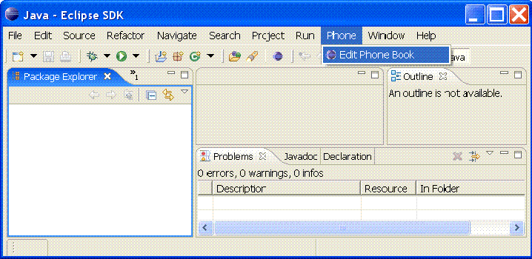

Clicking on "Edit Phone Book" menu item causes the Edit PhoneBook Dialog to be displayed:

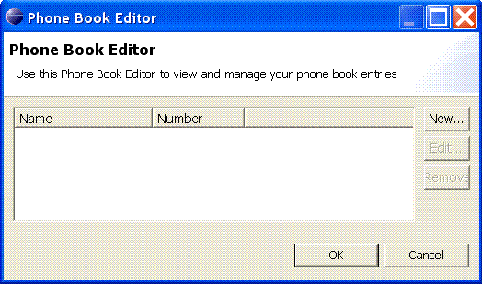

Clicking on "New" button causes the Edit PhoneBook Entry Dialog to be displayed:

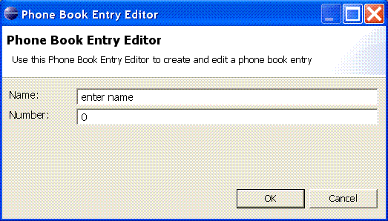

***Making GUI Classes testable using package protection***

 Throughout the simple GUI examples provided here, a deliberate style of making all fields in GUI classes *package protected* has been followed. **Making the fields package protected allows the unit tests to access the GUI components during a test run**.

For example, the local variables  are all package protected.

package phonebookexample.dialogs;  
...  
public class PhoneBookEntryEditorDialog extends TitleAreaDialog {

PhoneBookEntry phoneBookEntry;

Composite phoneBookEntryComposite;

Text nameText;

Text numberText;

...

}

Note that this is not an ideal solution for making your GUI classes testable, but it is simple and it works.

**Appendix B: Example PDE Unit Tests (PhoneBookExample-test)**

There is just a single PDE JUnit test class provided in the example (PhoneBookEntryEditorDialogTest) and most of the tests there are pretty straightforward, but there are a few tricks or techniques that do require some further explanation.

***Accessing the active shell***

 The active shell for your GUI under test can be accessed using the following:

PlatformUI.getWorkbench().getActiveWorkbenchWindow().getShell()

***Extending the GUI class under test to access protected methods***

 This is a simple technique to **allow your test to gain access to protected methods in the class under test or one of it's super classes.** In the example the local class MyPhoneBookEntryEditorDialog extends the class under test PhoneBookEntryEditorDialog so that the tests can access the, getButton(int id), buttonPressed() and cancellPressed() methods these methods can then be used in the tests.

class MyPhoneBookEntryEditorDialog **extends PhoneBookEntryEditorDialog** {

public MyPhoneBookEntryEditorDialog(Shell parent, PhoneBookEntry phoneBookEntry) {

super(parent, phoneBookEntry);

}

@Override

protected void buttonPressed(int buttonId) {

super.buttonPressed(buttonId);

}

@Override

protected void cancelPressed() {

super.cancelPressed();

}

@Override

protected Button getButton(int id) {

return super.getButton(id);

}

}

***Making GUI Classes testable using package protection***

**Making the local variables package protected allows the unit tests to access the GUI components during the rest run** (see the [**earlier section**](http://www.eclipse.org/articles/Article-PDEJUnitAntAutomation/article.html#Making_GUI_Classes_testable_using)for further details).

**Acknowledgements**

This technique for automating PDE unit tests was first developed by David Bosschaert at IONA Technologies.

I'd like to thank Edwin Dankert and Sean Boylan, both of Duolog Technologies who helped refine the technique and the article. I'd also like to thank the reviewers Edwin Dankert, David Bosschaert, Andrew Niefer of IBM and Wayne Beaton of Eclipse for taking the time to read the article and provide all the excellent feedback.

**Legal Notices**

Java and all Java-based trademarks and logos are trademarks or registered trademarks of Sun Microsystems, Inc. in the United States, other countries, or both.